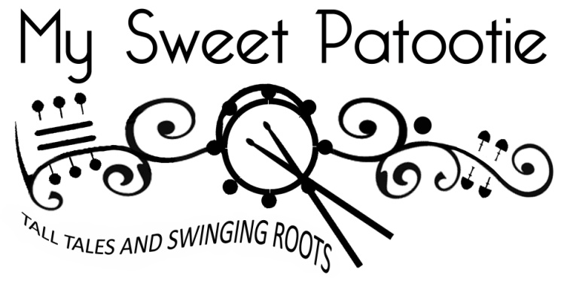
My Sweet Patootie embraces the fun that makes live music so intoxicating. With a sly wink and a grin, they draw you into a world of carnival barkers and nostalgic romantics; making you feel like you're a part of it all. Shades of vintage swing, country blues, folk, and ragtime collide in an uplifting and humorous show performed with tight vocal harmonies and instrumental virtuosity. It's a unique musical experience that transcends the borders of the acoustic-roots genre, promising to entertain music lovers of all kinds.

This dynamic trio features Canadian Folk Music Award winners Sandra Swannell on vocals/violin and singer-guitarist Terry Young who's flashy fingerpicking functions simultaneously as the group’s guitar and bass. Devonshire drummer John Jackson rounds out their sound on ricky-tick percussion.

"Hot guitar, fiery fiddle and swinging percussion together in a classy blend of multi-genre Americana roots styles, but place the emphasis firmly on having fun. It's an irresistible combination that makes them one of the cheeriest acts on the circuit and a 'must-see'. If you're a promoter, you won’t regret booking them; if you love a good time, go see 'em - you'll leave their show with a smile on your face!"
Kev Buxton, Kontra Roots Promotions, UK

Since 2007 My Sweet Patootie has been bringing communities together through memorable, engaging performances with an emphasis on entertainment, high quality musicianship and family-friendly fun. The band has released 4 full-length albums and tours regularly across Canada, the USA and the UK.

The band's name "My Sweet Patootie" is 1920’s slang, a term of endearment from North America meaning "hot dame" or "sassy sweetheart". It captures the vintage flavour of the band’s music and the satirical edge in much of their songwriting. Several ragtime titles from the jazz-age reference the expression, as do the lyrics of "Everybody Loves My Baby" (1924) by Spencer Williams and Jack Palmer. More significantly for Young and Swannell is "Sweet Patootie Blues" (1928) by Arthur "Blind" Blake, who was well known for his complex and intricate finger picking.

Terry Young is described by Penguin Eggs as an “acoustic guitar god”. BBC critic James Harrox calls his playing "virtuosic", while FATEA magazine describes it as "jaw dropping". He has taught advanced fingerstyle guitar clinics and has written about his technique for Chicago's Plank Road Folk Music Society Magazine. He is a talented multi-instrumentalist who toured from 1999 - 2009 with the group, Tanglefoot; performing on guitar, mandolin, banjo, and pennywhistle. Terry is a classically trained singer and holds a Bachelor of Music from the University of Western Ontario.

Sandra Swannell is a classically trained violinist/ violist, but her style owes much more to the influences of Joe Venuti and Stephane Grappelli. Her diverse musical background ranges from recording with Canada's legendary Stompin' Tom Connors to writing a series of musical sketches for string orchestra. She was the principal violist of the Georgian Bay Symphony and fronted the Celtic art-rock band The Shards before joining the group, Tanglefoot in 2005. Sandra has taught violin/ viola clinics for festivals, schools, community orchestras for many years as well as her own private studio.

With the departure of group's original drummer Bradford Nowak in 2015, My Sweet Patootie became a truly international band with percussionist John Jackson from Devon joining for UK tours, and Canadian Paul Clifford for North American tours.

Devonshire drummer, guitarist and former DJ John Jackson has an eclectic mix of musical inspiration, ranging from Genesis to Johnny Cash. His drumming experience includes concert bands, theatre pit work, playing cajon for acoustic acts, and working with trock and roll function bands.

