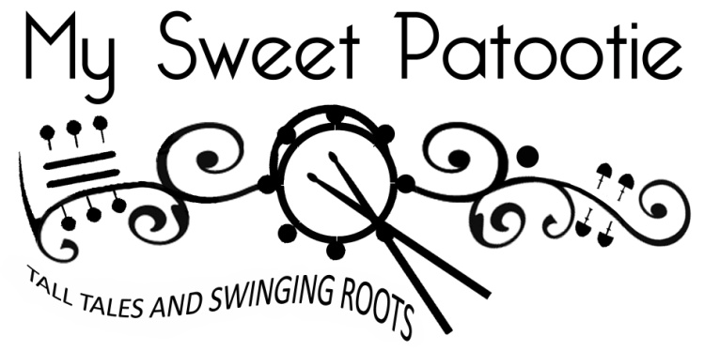
My Sweet Patootie embraces the fun that makes live music so intoxicating. With a sly wink and a grin, they draw you into a world of carnival barkers and nostalgic romantics; making you feel like you're a part of it all. Shades of vintage swing, country blues, folk, and ragtime collide in an uplifting and humorous show performed with tight vocal harmonies and instrumental virtuosity. It's a unique musical experience that transcends the borders of the acoustic-roots genre, promising to entertain music lovers of all kinds.

This dynamic trio features Canadian Folk Music Award winners Sandra Swannell on vocals/violin, and singer-guitarist Terry Young who’s stunning fingerpicking functions simultaneously as the group’s guitar and bass. Devonshire drummer John Jackson rounds out their sound on ricky-tick percussion.

The band's name "My Sweet Patootie" is 1920’s slang, a term of endearment from North America meaning "hot dame" or "sassy sweetheart". It captures the vintage flavour of the band’s music and the satirical edge in much of their songwriting.

Since 2007 My Sweet Patootie has been bringing communities together through memorable, engaging performances with an emphasis on entertainment, high quality musicianship and family-friendly fun. The band has released 4 full-length albums and tours regularly across Canada, the USA and the UK.

__________________________________________________________________________

"Hot guitar, fiery fiddle and swinging percussion together in a classy blend of multi-genre Americana roots styles, but place the emphasis firmly on having fun. It's an irresistible combination that makes them one of the cheeriest acts on the circuit and a 'must-see'. If you're a promoter, you won’t regret booking them; if you love a good time, go see 'em - you'll leave their show with a smile on your face!"
Kev Buxton, Kontra Roots Promotions, UK

"With their arsenal of instrumental virtuosity combined with alternating humour and sincerity and unflagging energy, they filled the hall with joy."
​Bill Monahan, Meaford Live Music

